

Department | FED
Subject | DSA-2
Academic Year | I-III Semester(2025-26)
Faculty Name | Gopi Krishna
Student Name | V Sri Bhargavi
Roll Number | 2520040048
Branch | ECE
Course Outcome | 1

Case Study Topic: Optimal Activity Profit Calculation using Weighted Job Scheduling (Dynamic Programming)”

Work Done Summary:
- In this case study, Weighted Job Scheduling was implemented to maximize total profit from non-overlapping jobs. Jobs with start time, end time, and profit were sorted by finish time, and a DP table was used to select the optimal combination of jobs.
Implementation Details:
- Created a Job class representing each activity.
- Sorted all jobs by their ending time.
- Implemented binary/linear search to find non-conflicting jobs.
- Constructed a dynamic programming table to calculate optimal profit.
- Selected jobs that contributed to maximum accumulated profit.
- Compared DP output with a greedy approach showing DP is superior.
Result: Screenshots :
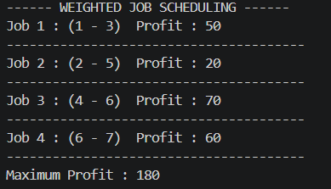
Dynamic Programming was used to compute the maximum profit schedule for non-overlapping jobs.
Selected jobs produced a maximum profit of 180.
Jobs considered:
(1–3 → 50), (2–5 → 20), (4–6 → 70), (6–7 → 60)
Time Complexity:
• DP Table Construction: O(n log n)

GitHub Link: https://github.com/sribhargavivaddavalli-svg/DSA_CASESTUDIES

